Sensory Trays:
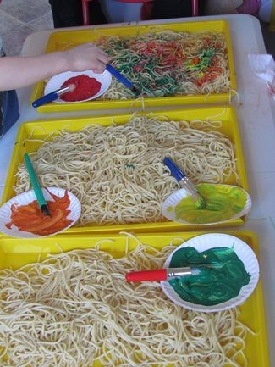 Boil one large box of spaghetti noodles and then set the cooked spaghetti out on a tray along several kitchen tools including “wooden toaster tongs” and scissors for the children to work on their cutting skills….
Throughout the day add a little water to the spaghetti when the noodles started to get too sticky. I shared with the kids how adding a touch of water would make the spaghetti more slippery again… Then the children can paint the spaghetti (use paper plates of paint and some paint brushes too…)
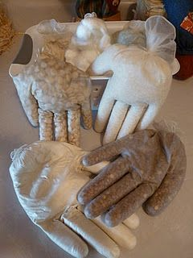 Sensory Hands...These are cheap and easy to make and virtually free to make. I used non-latex gloves, fill each glove with a different texture (flour, rice, split peas, kidney beans, cotton balls, oatmeal and I think they are red beans). Any filling will work and flour is the favourite one. It is super soft and fun to play with. I used string and made lots of knots to tie them off. I have had these hands for a couple of years and they have yet to break open. But if they do, they are easy to re-make.
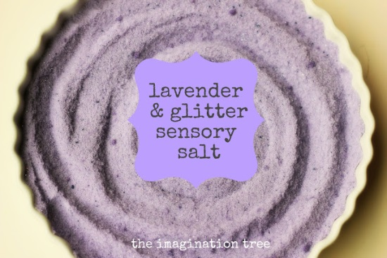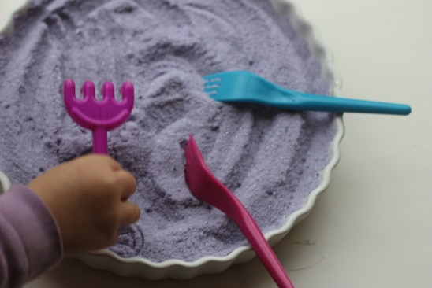
To build on that play time we created some new sensory salt, this time adding purple colouring, lavender essential oil and silver glitter. It truly is the most marvellous sensory material ever! So wonderfully soft and smooth, it pours so well between containers, feels lovely between your fingers (and toes!) and can be raked, drawn in, moulded, smoothed and used to create patterns and impressions. To build on that play time we created some new sensory salt, this time adding purple colouring, lavender essential oil and silver glitter. It truly is the most marvellous sensory material ever! So wonderfully soft and smooth, it pours so well between containers, feels lovely between your fingers (and toes!) and can be raked, drawn in, moulded, smoothed and used to create patterns and impressions.
How to make sensory salt:
- Pour some fine salt into a zip-loc bag
- Add a few drops of liquid food colouring (or gel colouring mixed with a few drops of water) shake it up and mix with fingers through the bag until all colour is combined
- Add glitter and a few drops of essential oil and shake again PLAY!!
- Store in an airtight container indefinitely. We poured it out on a table top that had been lined with tin foil, with a little edge created all the way around by scrunching up the foil to form a barrier. This gave it a shiny underlay that would reflect beautifully when marks were made. To the salt we added feathers, a potato masher, a little rake, forks, cups and fingers!
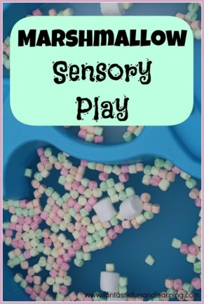 We have a water table that has two sections. We filled one side with cold water and one side with warm water. Then the kids added a bunch of marshmallows. We used different sizes and colours.
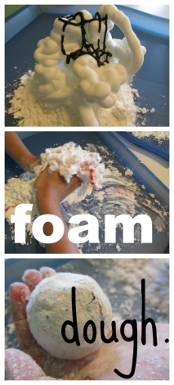
Materials:
- Shaving cream
- Cornstarch
- Food coloring (optional)
- Cups, spoons, bowls, play dough toys, etc. (optional)
Step 1: There’s only one step! Just pour any amount of cornstarch, and squirt about the same amount of shaving cream on top of the cornstarch (you can add more of either if you need to as you mix it until you get a mouldable dough). Then just mix it by squishing it with your fingers (my daughter really loved this part!). You can also add some food colouring if you want to add some colour. That’s it! Super easy. Super quick. Super fun! Enjoy!

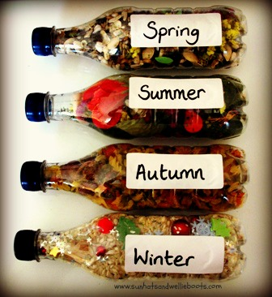
We started with Winter & for this we used; arborio risotto rice (the pearly risotto rice has a glossy, smooth texture making it perfect to represent snow), silver glitter/stars, mini red pompoms/bells (to represent berries), mini silver & white pompoms (to represent snowballs), a couple of stars, & a few foam shapes (holly leaves, small Christmas tree, snowflakes, & a tiny gingerbread man).
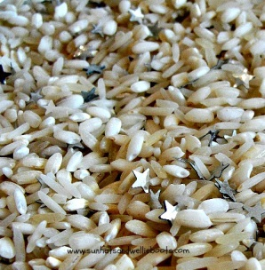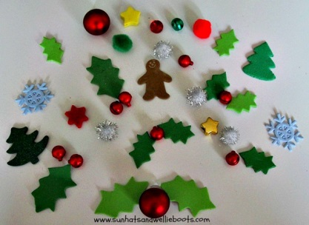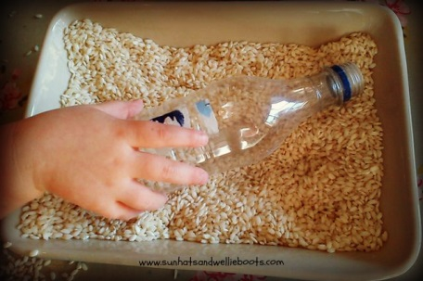
Start by mixing the silver stars with the rice in a baking dish, then scooped a little of the mixture into the bottle.

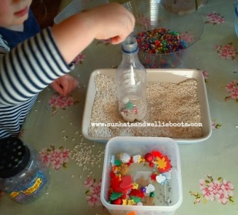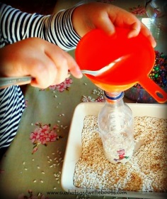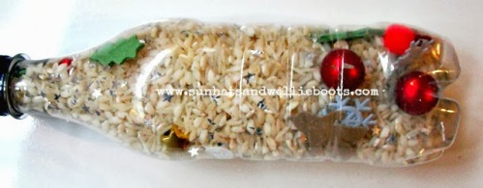

Then Minnie discovered a funnel was so much easier to use & continued to fill using a spoon. (Great for observing a child's hand-eye co-ordination & motor skills.)

When the contents had reached the neck of the bottle we added the lid & secured with strong glue. Alternatively you could seal with tape.

Then we moved on to create our Autumn bottle. For this we used: tricolor pasta shapes, a collection of finds from our nature walks (acorns, conkers, mini pine cones, sticks, leaves, beechnuts, walnuts) & a few silk petals in autumnal colours.
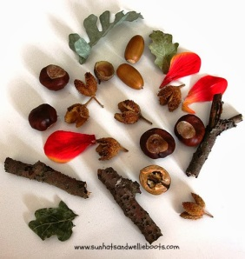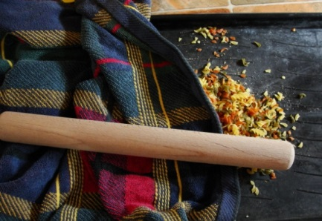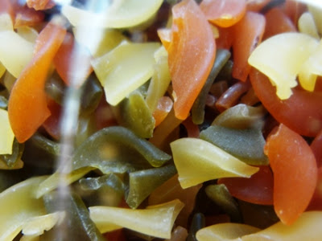
To create smaller pasta shapes we poured the pasta onto an old tray, placed an old towel over the top & crushed the pasta with a rolling pin. Minnie had great fun banging the rolling pin over the towel & then rolling it over the bumps. A great way to observe gross motor skills & great to see her energy as she excitedly rolled (& thumped) the rolling pin over the pasta.
When the pasta had been pounded add it to the bottle as before, along with mini autumnal finds. We discovered that adding a little filler (pasta) first, then adding an item or two, followed by more filler & then repeating gave the best results.
The tricolor pasta created some great autumnal colour in the bottle. Lentils would make a good alternative, we just used the pasta as it was in our cupboard at the time, & I knew Minnie would love hammering the pasta & creating lots of noise! The bottle was sealed as before, then ready to investigate.
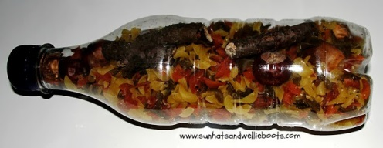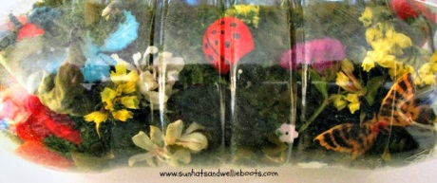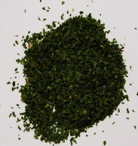
Our Summer bottle was our next creation, & for this we used three small jars of dried parsley, dried statice flowers, small silk flowers in a mix of bright colours, dried peas & beans, mini plastic butterflies & bees, & small ladybirds.
The dried parsley represented grass, & was a nice addition to the summer bottle as it's one of the herbs Minnie has been growing in her garden area. We sealed as before, & our summer bottle was complete.
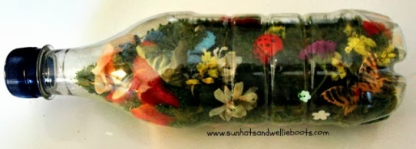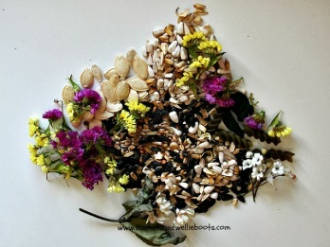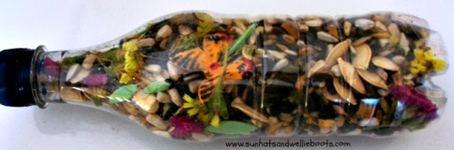

Finally our Spring bottle. For this was used; flower seeds (collected from our garden a few weeks ago), pumpkin seeds, dry bird food (small seeds), dried statice flowers, green silk leaves, sprigs of silk blossom, a few small leaves cut from green foam, a plastic butterfly & spider.
As Spring is the season for planting seeds it seemed appropriate to add them to this Spring discovery bottle. Hopefully the few small flowers & tiny green leaves will represent the new life that Spring brings. It's nice to think that Minnie collected these seeds from plants she sowed last Spring.

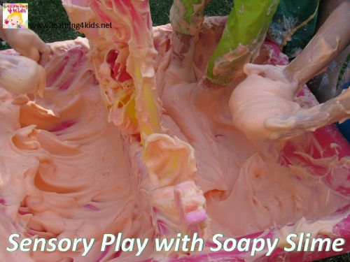 To make Soapy Slime you will need 1 cup of Soap Flakes, 3 cups warm water, food colouring, large mixing bowl, large container or tray and an electric beater. You can find soap flakes at your local supermarket in the washing powder isle. As you beat the water, food colouring and soap flakes the mixture multiples, so I placed the large bowl on top of our container to catch the over flow.

